Management and Leadership
GIZ Program Georgia

Modul2: Managing an Organization (1)

Bert Baks
Hans Rieger

1. Normative modern management

Modern organizations are developing in the following direction:

 | Traditional administration | New Public Management
Structures | bureaucratic  hierarchic  centralist | strictly restricted centre  flat hierarchies  decentralised
Systems | strictly centralised control  detailed supervision performed on several levels | performance goals, bench marking, project groups, reporting, cost accounting, internal markets, decentralised resource management, quality management
Personnel | large number of staff  permanent, fixed,  periodic promotion | small core staff  flexible, large ”periphery”, continuous training and further vocational training,  achievement principle
Role/culture | authoritarian thinking  legal and financial honesty  professionalism  quantity of public achievements | flexible management  responsibility for results  management: focus on customers’ needs/ quality of achievements

Nowadays also other concepts of administration than pure NPM arise. Those apart from managerial part put also attention on values, that can be universal characteristics for good governance:
- Co-operation of all stake holders in the organization
- Transparency
- Equality (in law and in front of the law)
- Ethics and integrity
- Responsibility
- gender
This approaches are topic in Module 3.
To follow the direction towards NPM, the top management of an organization has to implement several tools and instruments.

Asking staff members what are they missing from their managers the answer has very often 2 dimensions:
- Communication
- Clear task and objective

In this chapter we focus on the second point.

What is the Strategic Plan?

A strategic plan describes the purpose, or mission, of an organization, the major challenges it faces and the goals and strategies it will use to meet those challenges.

Organizations develop strategic plans so that everyone, from the Chief Executive Officer to “front line” employees, will know what is important to the organization and what it is trying to accomplish.

Some strategic plans also include a “vision” for the organization, which is a statement of a desired future that all employees can work to achieve together.

1.1 Vision

To get started there should be a clear vision what the particular organization stands for. It is a most abstract the vision statement.
Definition:
A vision statement can be called a picture of your organization in the future but it is so much more than that. Your vision statement is your inspiration, the framework for all your strategic planning which you develop based on the vision statement.
What you are doing when creating a vision statement is articulating your dreams and hopes for your organization. It reminds you of what you are trying to build.
Whether for all or part of an organization, the vision statement answers the question, "Where do we want to develop ourselves?"
The following are examples for vision statements. Sometimes a vision statement can be summarized in one sentence. Examples include:
- To help people be safe,
- To help people to get an affordable solution to health care,
- A just world without poverty (Oxfam, 5 words)
- A hunger-free America (Feeding America, 4 words)
- Equality for everyone (Human Rights Campaign, 3 words)

Local organizations might aspire to be the best organization in the country. Vision statements may also be longer as well. Some examples include:
- The Organization will inspire its employees to be the best they can be. “We will engage in sustainable practices and anticipate the needs of our citizens. We will maximize return to the country while still maintaining quality in our work and results.”
- To become a world leader at connecting people to wildlife and conservation (San Diego ZOO, 12 words)

In each of these examples, the vision statement helps to define goals, creating something to work towards in the future.
Examples for further Vision statements:
- The Court and its employees strive to become recognized for their service excellence, dedication, integrity, impartiality, competence and diversity, as well as their commitment to ensuring equal access to court services and enhancing public confidence in the court system (Superior Court of California, County of Alameda).
- Vision Statement defines the desired state of the Court in the future and provides us with a reference point as to how we would like the Court to operate in the future. The Justice of the Peace Court will:
- Be sensitive and responsive to the needs of a diverse community.
- Use cutting edge technology to increase: citizens' access and convenience in using the Court and the Court's ability to reach sound decisions through the best available access to factual and legal information.
- Treat all individuals using the Courts with the utmost respect.
- Have a service oriented approach in dealing with users of the Court.
- Use strategic planning to develop and maintain the highest possible level of services to the public and to responsibly seek, use and account for public resources.
- Insure that court procedures and structure best facilitate the expeditious and economical resolution to disputes.
- Insure equal application of the judicial process to all cases, which are fairly decided based upon legally relevant factors.

Writing a Good Vision Statement
Looking at these vision statement examples should give you a good jumping off point for knowing what a vision statement is and how to write one. Vision statements are a challenge for many people because they aren't sure what form the statement is supposed to take.
- A typical organizartion´s vision statement will be brief and succinct; it will say a lot in just a few words, so those words must be very carefully chosen.
- The key to a good vision statement is to think of things in a long-term, broad sense, without sounding generic.
- If you're too specific, you will limit your vision and it won't be applicable ten years down the road: for example, if your current goal for your organization is to move into a larger building, that's a vision for the future but it's not the vision for the future of your entire organization. It's too narrow in focus.
- On the other hand, if you say that you want to achieve success – well, any organization in the world could say that. It's too generic. The best statement will be clear about who you are as a organisatioin as well as who you wish to become.
IN SHORT:
VISION STATEMENT (DESIRED END Version)
A one sentence statement describing the clear and inspirational long-term change, resulting from your work.
These should be practical, tangible tools you can use to lead your group or organization in achieving quality results.
NEEDS TO…
- …be clear and simple
- …avoid elaborate language & buzz words
- …easily explained by those involved
QUESTIONS TO CONSIDER
What needs to be changed?
Why should issues be addressed?
What are the strengths and assets?
What is your dream end-version?
What would success look like?
Writing a good vision statement isn't difficult. Think about what your organization does and what, in an ideal world, you would like it to do and how you would like to appear to the outside world. Consider the services and attributes that your organization provides. Then imagine how it would be if you provided the very best version of them possible. List those visions, and incorporate them into a brief statement that gives a good overview of the kind of image you want to represent.
Understanding your goals and being able to state them clearly is the first step toward making them happen and to give clear way forward to your staff members as well.
WHAT DOES THIS MEANS FOR YOU?

Is your vision statement longer than 20 words? Can you get it below 15? Below 10? Design your vision statement to clearly communicate what you are working to achieve in a way that people can remember and communicate this to others. If you can’t get your full vision below 15 words, consider also vision tagline (2-6 words) which people can more easily remember.

Exercise 1: Formulation of Vision Statement
Formulate a vision statement for the your Organization in Georgia in Georgia.

1.2 Mission statement

Having the vision in place the next step is to formulate a mission statement. Out of the formulated and shared vision the mission statement gives already direction where the organization has to develop to.
Definition:
A mission statement is a statement of the purpose of an organization. Its reason for existing; a written declaration of an organization's core purpose and focus that normally remains unchanged over a long period of time.
Properly crafted mission statements serve as filters to separate
- what is important from what is not,
- clearly state which position the organization has and will be served and how,
- communicate a sense of intended direction to the entire organization.
A mission is different from a vision in that the former is the cause and the latter is the effect; a mission is something to be accomplished whereas a vision is something to be pursued for that accomplishment.
The mission statement should guide the actions of the organization, spell out its overall goal, provide a path, and guide decision-making. It provides "the framework or context within which the organization´s strategies are formulated." It is like a goal for what the organization wants to do for their country.

Examples for mission statements:

Mission Statement Inspector General:
The mission of the Office of the Inspector General (OIG) is to provide strong, independent and effective oversight of the Los Angeles Police Department (LAPD) and to ensure that the LAPD, its officers, and employees act with honesty, integrity, dignity, and respect towards the public, as well as ensuring that both the OIG's as well as the LAPD's responsibilities under the Federal Consent Decree with the U.S. Department of Justice (Consent Decree) are being met. In addition, the OIG conducts community outreach to educate the community about the OIG, the Police Commission (Commission), and the LAPD on a periodic basis, but especially in the wake of high-profile use of force incidents and other newsworthy developments of particular interest to the community. The OIG carries out its mission through three discrete sections: the Complaint Section, the Audit Section, and the Use of Force section. The responsibilities and objectives of each section are described below

Mission Statement Superior Court:
The San Francisco Superior Court is a court in California that takes care of all adjudication matters. Their court is divided into the following: the Civil Division , Criminal Division, Drug Court, Traffic Division, Unified Family Court, YGC Juvenile Delinquency, etc.

Mission Statement:
The purpose of the San Francisco Superior Court is to assure equal access, fair treatment, and the just and efficient resolution of disputes for all people asserting their rights under the law.

Mission Statement, Superior Court of California, County of Alameda
The Court shall fairly and efficiently resolve disputes arising under the law and shall apply the the law consistently, impartially, and independently to protect the rights and liberties guaranteed by the Constitutions of California and the United States. The employees of the Court shall strive for service excellence and through their dedication and professionalism, implement the policies and procedures established by the judiciary and legislature. The judges and employees are committed to ensuring equal access to court services and enhancing public confidence in the court system.

A process for developing a useful mission statement boils down into five steps:

1. Start with a “market-defining” story
Do think it through: Imagine a real citizen or party being your client or customer. Use your imagination to see why want, need and what they are doing with your services and decisions. The more concrete the imagination, the better.
A really good mission statement defines the target customers. And it defines how your tasks is different from most others, or even unique.

2. Define how your citizens life is better because your organization exists
Start your mission statement with the good you do. Use your market-defining story to trigger out whatever it is that makes your tasks special for Georgian society.
Don’t undervalue your task. This is a part of your mission statement, and a pretty crucial part at that—write it down.

3. Consider what your organization does for own staff
These days, good organizations want to be good for their employees. If you’re interested in culture and staff satisfaction, then defining what your organization offers its employees is an obvious part of your strategy.
Stating that you value fair compensation, room to grow, training, a healthy, creative work environment, and respect for diversity is probably a good idea, even if that part of your mission statement isn’t unique. That’s because the mission statement can serve as a reminder—for owners, supervisors, and workers—and as a lever for self-enforcement.
If you have a special view on your relationship with employees, write it into the mission statement. If your organization is friendly to families, or to remote virtual workplaces, put that into your mission.

4. Add what your organization does for Georgia

The mission of management is to enhance the value of the country. The democratic country somehow the society is the owner of a court. Normally that goes without saying that a organization exists to enhance the position of its owner.

5. Discuss, digest, cut, review, revise
Whatever you wrote for points 2-4 above, go back and cut down the wordiness.
Good mission statements serve multiple functions, define objectives, and live for a long time. So edit. This step is worth it.
As you edit, keep a sharp eye out for the buzzwords and hype that everybody claims. Cut as much as you can that isn’t unique to your organization, except for those special elements that—unique or not—can serve as long-term rules and reminders.
Make sure you actually believe in what you’re writing—your customers and your employees will soon spot a lie.

Your mission statement is about you, your organization, and your ideals. Three key components are suggest:
- What are you doing for your clients / customers? This is something that sets you apart, makes you different, and that your Clients / customers will recognize.
- What are you doing for your employees? Fair compensation, good tools, professional development, encouragement, or whatever. If you’re serious about it, put it in the mission statement. If it’s in the mission statement, get serious about it.
- What does the organization do for its owners? Don’t apologize for needing profits to stay in business, or for generating return on investment for those who invested. Say it as part of your mission statement.

Additional tips for a mission statement:
- Don’t “box” yourself in. Your mission statement should be able to withstand the changes that come up over time in your product or service offerings, or customer base.
- Keep it short. The best mission statements tend to be 3-5 sentences long.
- Ask for input. Run your mission statement draft by your employees. Is it clear and easily understood, or does it sound artificial or academic.
- Aim for substance, not superlatives. Avoid saying how great you are, what great quality and what great service you provide.

IN SHORT:

MISSION STATEMENT (WHY YOU EXIST)

A one sentence statement describing the reason an organization exists.
This should be a practical, tangible tool you can use to make decisions about priorities, actions, and responsibilities.

NEEDS TO…
- …be clear and simple
- …avoid elaborate language & buzz words
- …easily explained by others
- …not be confused with a vision statement
- …be recognizably yours

1-5 WORD ANSWERS

What type of entity? Is this important?
Why do you exist? (problem/needs)
What’s the broadest way to describe the work?
For whom do you do this work?
Where do you work? (geographic boundaries)

Exercise 1.2: Mission statement
Formulate a Mission statement for your Organization in Georgia.
Follow the 5 steps mentioned in the text.
Do not forget about the dimensions
- Customers, clients citizens
- Staff members
- State of Georgia

Example – Supreme Court of Singapore
Mission
- Integrity and Independence
Public trust and confidence in the Supreme Court rests on its integrity and the transparency of its processes. The public must be assured that court decisions are fair and independent, court staff are incorruptible, and court records are accurate.
- Quality Public Service
As a public institution dedicated to the administration of justice, the Supreme Court seeks to tailor its processes to meet the needs of court users. We therefore adopt a customer-focused approach to the development of our services, with an emphasis on the accessibility, quality and timely delivery of services.
- Learning and Innovation
The Supreme Court recognises that to be a world-class Judiciary, we need to continually improve ourselves and our processes. We therefore encourage learning and innovation to take the Supreme Court to the highest levels of performance.
- Ownership
We value the contributions of our staff and our staff are committed and proud to be part of the Supreme Court.
Example – District of Columbia Courts
Vision
Open to All, Trusted by All, Justice for All

Mission
To protect rights and liberties, uphold and interpret the law, and resolve disputes peacefully, fairly and effectively in the District of Columbia.

Goals
The Plan identifies 5 priority areas, called goals, to be addressed. The goals are:
1. Fair and Timely Case Resolution
2. Access to Justice
3. A Strong Judiciary and Workforce
4. A Sound Infrastructure
5. Public Trust and Confidence
Within each goal, the Plan identifies objectives to be accomplished and strategies to accomplish them. For example, Objective 2A under Access to Justice is: the D.C. Courts will ensure access to court services for all persons. One of the strategies to accomplish this goal is to increase the establishment of community-based service centers and provide additional after-hours services.

Values
One element of the 2013-2017 Strategic Plan is an updated statement of Court Values. Whereas the Vision statement describes the Courts’ preferred future and the Mission statement describes our purpose, the Values describe how we achieve our purpose – the means and methods of accomplishing the Courts’ work.

The DC Courts’ Strategic Plan contains A Strong Judiciary and Workforce goal. The selection of Values to support the objectives under this, as well as all of the Plan’s objectives, was critical. An organization can produce a great product or service, but if it uses unethical or illegal means to do so, or treats its people poorly, or employs other practices which reflect questionable values, it will eventually be subject to criticism, scrutiny or failure.

1.3 Strategy

Definition
1. A method or plan chosen to bring about a desired future, such as achievement of a goal or solution to a problem.
2. The art and science of planning and marshalling resources for their most efficient and effective use.
For example, and depending on scope and circumstances, you may want to develop strategies i.e. to:
- Increase approval ratings,
- boost customer / citizens satisfaction
- Complete a project under budget

Strategy creation follows a three-stage process:
- Analyzing the context in which you're operating. This is also based on your mission statement.
- Identifying strategic options
- Evaluating and selecting the best options.

Stage 1: Analyzing Your Context and Environment
In this first stage, you ensure that you fully understand yourself and your environment. Do the following: Analyze Your Organization
Firstly, examine your resources, liabilities, capabilities, strengths, and weaknesses. A SWOT Analysis is a great tool for uncovering what you do well and where you have weaknesses, providing that you use it rigorously. It's much easier to achieve your objectives when your strategy uses your strengths without exposing your weaknesses. Also, look at your Core Competencies.
Analyze Your Environment. Now you need to examine your current operating environment to predict where things are moving. Are there exciting opportunities that you should pursue? What future scenarios are likely in your environment, and how will these impact the work that you do?
As you prepare to create your strategy, make sure that you're working in a way that's aligned with changes in your operating environment, rather than working against them. These external factors are often beyond your control, so if you pursue a strategy that requires a change in one of these elements, you may have a long, exhausting, unprofitable battle ahead of you.
Analyze Your Clients: Your strategy defines how you'll win, and winning is typically framed by how well you satisfy your clients. Governments, nonprofits, and project teams all have other stakeholders to satisfy as well. Strategy creation must consider these needs.
Identify your clients and stakeholders. What do your clients want? And who are the key stakeholders in your success? A Stakeholder Analysis will help you uncover these needs and preferences.

Stage 2: Identifying Strategic Options
In Stage 1, you developed an understanding of how your organization or team fits within the context of the internal and external environments. Now it's time to think about the different things that you could do to create a clear advantage, and meet your objectives. Here are some fundamental activities that can help you make this decision.
Brainstorm Options: Use creativity tools like Brainstorming or Reverse Brainstorming to explore projects that you could run to develop competitive advantage.
Examine Opportunities and Threats: Your SWOT Analysis identified some of the main opportunities and threats you face. Using this as a starting point, brainstorm additional ways to maximize your opportunities, minimize your threats, or perhaps even turn your threats into opportunities.
Solve Problems: A problem-solving approach can also help at this stage. If your problem is that you're not achieving your goals, ask yourself how you can ensure that you do

Stage 3: Evaluating and Selecting Strategic Options
The final stage is to evaluate strategic options in detail, and select the ones that you want to pursue.
Evaluate Options: By this stage, you've probably identified a range of good projects that you could run. You must now evaluate these to choose the best strategic options. Consider every option you've identified, but don't make a final judgment until you've completed your assessment.
Start by evaluating each option in the light of the contextual factors you identified in Stage 1.
Techniques like Risk Analysis , Failure Modes and Impact Analysis can help you spot the possible negative consequences of each option, which can be very easy to miss.
Many options will be analyzed on a financial basis. Here, techniques like Cost-Benefit Analysis are helpful.
Choose the Best Way Forward: With your evaluation complete, you now must choose the best strategic option or strategic options, making sure that you don't choose so many options that you spread your resources too thinly.

1.3.1 Strength / Weaknesses and Opportunities / Threats Analyzes (SWOT-Analyses)

The point of a SWOT analysis is to help you develop a strong strategy by making sure you’ve considered all of your strengths and weaknesses, as well as the opportunities and threats it faces.
Strengths and weaknesses are internal to the organization. You can change them over time but not without some work. Opportunities and threats are external. They are out there in the environment, happening whether you like it or not. You can’t change them directly.
Existing organization can use a SWOT analysis, at any time, to assess a changing environment and respond proactively. In fact, it is recommended conducting a strategy review meeting at least once a year that begins with a SWOT analysis:

How to Conduct a SWOT Analysis
To get the most complete, objective results, a SWOT analysis is best conducted by a group of people with different perspectives and stakes in your organization. Moreover, the SWOT analysis process is an opportunity to bring your team together and encourage their participation in and adherence to your organization´s resulting strategy. A SWOT analysis is typically conducted using a four-square SWOT analysis template.
We recommend holding a brainstorming session to identify the factors in each of the four categories. Then meet to discuss and compile the results. As you work through each category, don’t be too concerned about elaborating at first; bullet points may be the best way to begin. Just capture the factors you believe are relevant in each of the four areas.
Once you are finished brainstorming, create a final, prioritized version of your SWOT analysis, listing the factors in each category in order from highest priority at the top to lowest priority at the bottom.
Questions to Ask During a SWOT Analysis
Find some questions below to help you develop each section of your SWOT analysis. There are certainly other questions you could ask; these are just meant to get you started.
Strengths (internal, positive factors):
Strengths describe the positive attributes, tangible and intangible, internal to your organization. They are within your control.
- What do you do well?
- What internal resources do you have?
- What advantages do you have?
- Do you have strong research and development capabilities?
- What other positive aspects, internal to your organization, add value?
Weaknesses (internal, negative factors)
Weaknesses are aspects of your organization that detract from the value you offer or place you at a competitive disadvantage. You need to enhance these areas in order to compete with your best competitor.
- What factors that are within your control detract from your ability to obtain or maintain a competitive edge?
- What areas need improvement to accomplish your objectives?
- What does your organization lack (for example, expertise or access to skills or technology)?
- Does your organization have limited resources?
- Is your organization in a poor location?

Opportunities (external, positive factors)
Opportunities are external attractive factors that represent reasons your organization is likely to prosper.
- What opportunities exist in your environment that you can benefit from?
- Is the perception of your organization positive?
- Is the opportunity ongoing, or is there just a window for it? In other words, how critical is your timing?

Threats (external, negative factors)
Threats include external factors beyond your control that could place your strategy, or the business itself, at risk. You have no control over these, but you may benefit by having contingency plans to address them if they should occur.
- Who are your existing competitors (i.e. for budget)?
- What factors beyond your control could place your organization at risk?
- Are there challenges created by an unfavorable trend or development that may lead to probems?
- What situations might threaten your efforts?
- Has a new product or technology been introduced that makes your products, equipment, or services difficult?

Developing Strategies from Your SWOT
Once you have identified and prioritized your SWOT results, you can use them to develop short-term and long-term strategies for your organization. After all, the true value of this exercise is in using the results to maximize the positive influences on your business and minimize the negative ones.
For example, look at the strengths you identified, and then come up with ways to use those strengths to maximize the opportunities (these are strength-opportunity strategies). Then, look at how those same strengths can be used to minimize the threats you identified (these are strength-threats strategies).
Continuing this process, use the opportunities you identified to develop strategies that will minimize the weaknesses (weakness-opportunity strategies) or avoid the threats (weakness-threats strategies).
The following table might help you organize the strategies in each area:
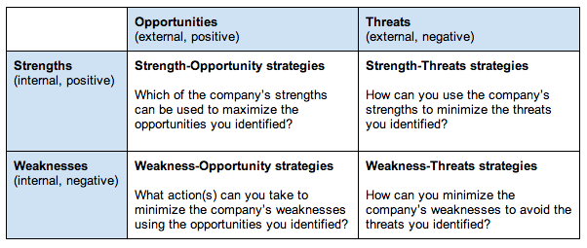

Once you’ve developed strategies and included them in your strategic plan, be sure to schedule regular review meetings. Use these meetings to talk about why the results of your strategies are different from what you’d planned (because they always will be) and decide what your team will do going forward.

1.3.2 Balanced score Card (BSC)

Balanced ScoreCard - Definition
What exactly is a Balanced Scorecard? A definition often quoted is: 'A strategic planning and management system used to align business activities to the vision statement of an organization'. More cynically, and in some cases realistically, a Balanced Scorecard attempts to translate the sometimes vague, pious hopes of a organization's vision/mission statement into the practicalities of managing the business better at every level.
A Balanced Scorecard approach is to take a holistic view of an organization and co-ordinate MDIs so that efficiencies are experienced by all departments and in a joined-up fashion.
To embark on the Balanced Scorecard path an organization first must know (and understand) the following:
- The organization's mission statement
- The organization's strategic plan/vision
Then
- The financial status of the organization
- How the organization is currently structured and operating
- The level of expertise of their employees
- Customer satisfaction level
The following table indicates what areas may be looked at for improvement (the areas are not exhaustive and are often organization-specific):

balanced scorecard - factors examples
Department | Areas
Finance | Return On Investment  used budgets  Return on Capital Employed  Financial Results (Quarterly/Yearly)
Internal Business Processes | Number of activities per function  Duplicate activities across functions  Process alignment (is the right process in the right department?)  Process bottlenecks  Process automation  Process described
Learning & Growth | Is there the correct level of expertise for the job?  Employee turnover  Job satisfaction  Training/Learning opportunities
Customer | Delivery performance to customer  Quality performance for customer  Customer satisfaction rate  Customer percentage of market  Customer retention rate

Once an organization has analysed the specific and quantifiable results of the above, they should be ready to utilise the Balanced Scorecard approach to improve the areas where they are deficient.
The metrics set up also must be SMART (commonly, Specific, Measurable, Achievable, Realistic and Timely) - you cannot improve on what you can't measure! Metrics must also be aligned with the organization's strategic plan.
A Balanced Scorecard approach generally has four perspectives:
- Financial
- Internal business processes
- Learning & Growth (human focus, or learning and development)
- Customer
Each of the four perspectives is inter-dependent - improvement in just one area is not necessarily a recipe for success in the other areas.
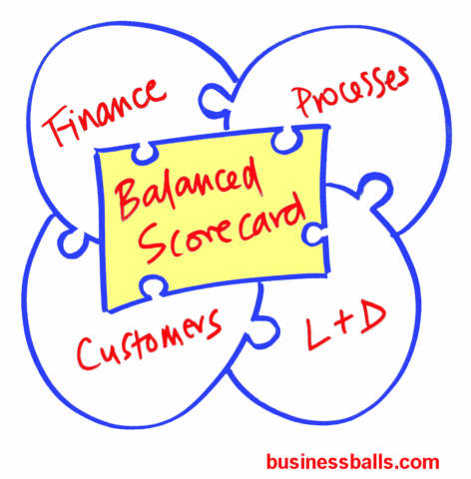

balance scorecard implementation
Implementing the Balanced Scorecard system organization-wide should be the key to the successful realisation of the strategic plan/vision.
A Balanced Scorecard should result in:
- Improved processes
- Motivated/educated employees
- Enhanced information systems
- Monitored progress
- Greater customer satisfaction
- Increased financial usage
Feedback is essential and should be ongoing and contributed to by everyone within the organization (remember module 1)
And it should be borne in mind that Balanced Scorecards do not necessarily enable better decision-making!

The balanced scorecard is a strategic planning and management system that is used extensively in, government, and nonprofit organizations worldwide to align business activities to the vision and strategy of the organization, improve internal and external communications, and monitor organization performance against strategic goals. It was originated by Drs. Robert Kaplan (Harvard Business School) and David Norton as a performance measurement framework that added strategic non-financial performance measures to traditional financial metrics to give managers and executives a more 'balanced' view of organizational performance.
The balanced scorecard has evolved from its early use as a simple performance measurement framework to a full strategic planning and management system. The “new” balanced scorecard transforms an organization’s strategic plan from an attractive but passive document into the "marching orders" for the organization on a daily basis. It provides a framework that not only provides performance measurements, but helps planners identify what should be done and measured. It enables executives to truly execute their strategies.
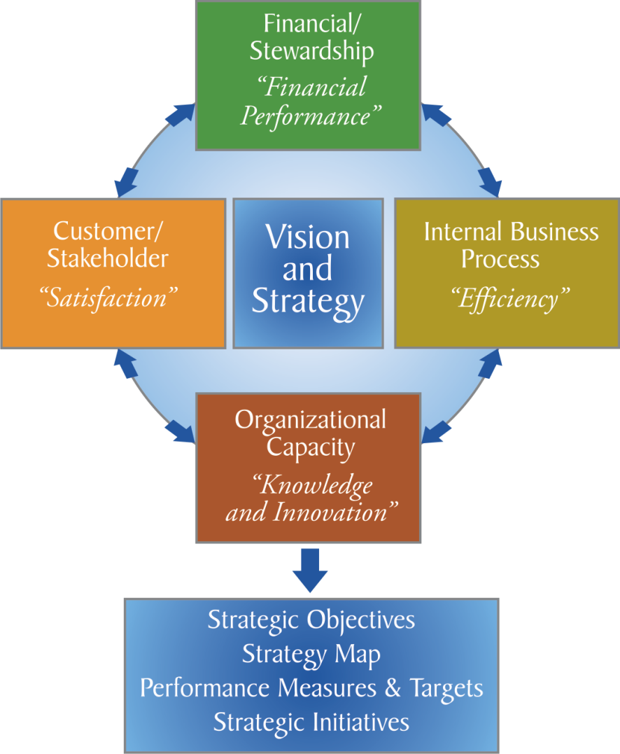

Perspectives
The balanced scorecard suggests that we view the organization from four perspectives, and to develop metrics, collect data and analyze it relative to each of these perspectives:
The Learning & Growth Perspective
This perspective includes employee training and corporate cultural attitudes related to both individual and corporate self-improvement. In a knowledge-worker organization, people -- the only repository of knowledge -- are the main resource. In the current climate of rapid technological change, it is becoming necessary for knowledge workers to be in a continuous learning mode. Metrics can be put into place to guide managers in focusing training funds where they can help the most. In any case, learning and growth constitute the essential foundation for success of any knowledge-worker organization.
Kaplan and Norton emphasize that 'learning' is more than 'training'; it also includes things like mentors and tutors within the organization, as well as that ease of communication among workers that allows them to readily get help on a problem when it is needed. It also includes technological tools; what the Baldrige criteria call "high performance work systems."
The Business Process Perspective
This perspective refers to internal business processes. Metrics based on this perspective allow the managers to know how well their business is running, and whether its products and services conform to customer requirements (the mission). These metrics have to be carefully designed by those who know these processes most intimately; with our unique missions these are not something that can be developed by outside consultants.
The Customer Perspective
Recent management philosophy has shown an increasing realization of the importance of customer focus and customer satisfaction in any business. These are leading indicators: if customers are not satisfied, they will eventually find other suppliers that will meet their needs. Poor performance from this perspective is thus a leading indicator of future decline, even though the current financial picture may look good.
In developing metrics for satisfaction, customers should be analyzed in terms of kinds of customers and the kinds of processes for which we are providing a product or service to those customer groups.
The Financial Perspective
Kaplan and Norton do not disregard the traditional need for financial data. Timely and accurate funding data will always be a priority, and managers will do whatever necessary to provide it. In fact, often there is more than enough handling and processing of financial data. With the implementation of a corporate database, it is hoped that more of the processing can be centralized and automated. But the point is that the current emphasis on financials leads to the "unbalanced" situation with regard to other perspectives. There is perhaps a need to include additional financial-related data, such as risk assessment and cost-benefit data, in this category.
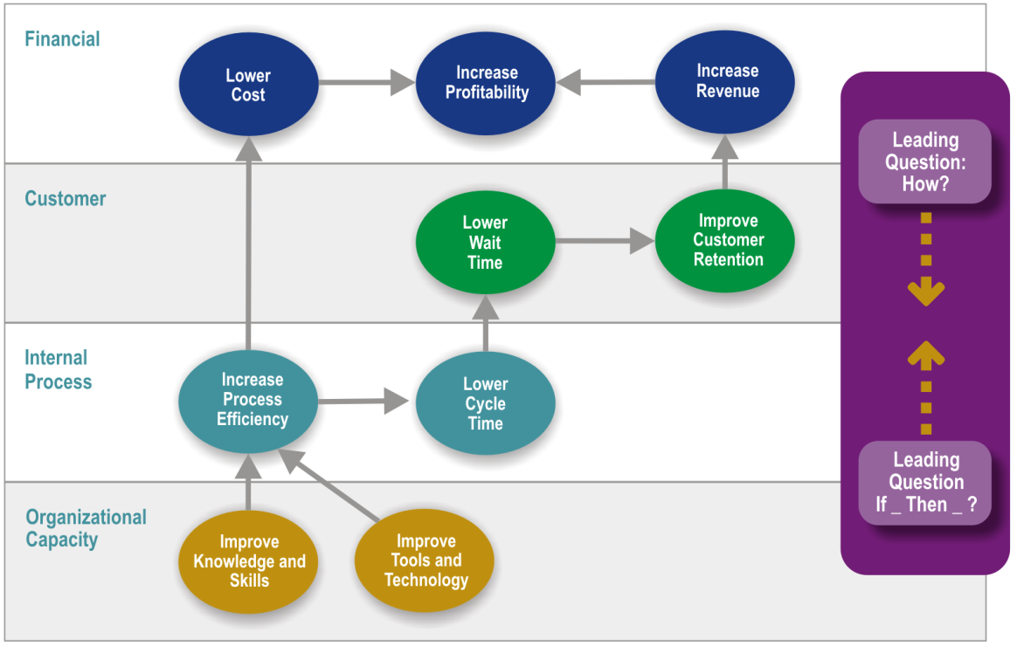
Reference: The Institute Way: Simplify Strategic Planning & Management with the Balanced Scorecard.

Attachment: Examples of a strategic plan with a set of objectives leading to an action plan (US)

Goal 1.0 To protect the rule of law.
Objectives:
1.1 To provide a reasonable opportunity for multi-judge review of decisions made by lower tribunals.
Strategies:
1.1(a) Judicial Participation. Judges are expected to participate in oral arguments, post-argument conferences, and writ conferences. Post-argument conferences where preliminary positions are articulated should be a part of every appellate cycle and judges should be encouraged to participate therein in a constructive way. Any absences by a judge from docketed hearings should be kept minimal in order to ensure full review of decisions coming to the appellate court.
1.1(b) Clerk of Court. The Courts of Appeal should maintain a sufficient number of highly qualified staff in the offices of the Clerk of Court to support and facilitate in the docketing process.
1.1(c) Judicial Staff. The Courts of Appeal should maintain a sufficient number of highly qualified attorneys and support staff in every judge's office to support and facilitate review of decisions in appeals and supervisory writ applications.
1.1(d) Central Staff. The Courts of Appeal should maintain a sufficient number of highly qualified attorneys and support staff in their Central Staff offices to support and facilitate the review of decisions made by lower tribunals in criminal and civil cases.
1.1(e) Recusal. Recusation of a Judge from a case is controlled by the Code of Civil Procedure Articles 151-161, Code of Criminal Procedure Articles 671-679, and Canon 3(C) of the Code of Judicial Conduct. The Courts of Appeal should discourage recusal not based on these grounds.
1.1(f) Random Selection. The Courts of Appeal should develop and maintain procedures to ensure that all appeals are randomly allotted to a particular panel either by drawing indiscriminately from a pool or by using a properly programmed electronic device.

1.2 To develop, clarify, and unify the law.
Strategies:
1.2(a) Judicial Legal Resources. The Courts of Appeal should have sufficient access to published and automated legal resources to facilitate clarifying, harmonizing, and developing the law, and maintaining uniformity in jurisprudence.
1.2(b) Collegiality. The Courts of Appeal should encourage and promote effective collegiality among its judges, which, by its very nature, will result in more uniformity in opinions. Included in such measures are panel conferences to promote coordination and resolution of minor disagreements that impact adversely on unanimity.

1.3 To determine expeditiously those petitions and/or applications for which no other adequate or speedy remedy exists, including mandamus, habeas corpus, quo warranto, termination of parental rights and other matters affecting children's rights, and election proceedings, and to consider expeditiously those writ applications filed under the court’s supervisory jurisdiction in which expedited consideration, or a stay, is required.
Strategies:
1.3(a) Expeditious Determination of Certain Case Types. The Courts of Appeal should identify those case types that should be determined expeditiously and should develop and implement court rules or procedures for the expeditious treatment of those cases.
1.3(b) Request Form for Expeditious Treatment. The Courts of Appeal should develop a form to be completed by any party requesting expeditious treatment of a filing to ensure that the filing meets all rule requirements, adequately sets forth the procedural posture of the case, and identifies the issues.
1.3(c) Development of Valid Grounds for Expediting Motions. The Courts of Appeal should develop and implement a court rule indicating the grounds to be stated in any request for expediting the consideration of motions. Page 4 of 14
1.3(d) Expeditious Determination of Certain Applications. The Courts of Appeal should expedite consideration of those applications in which the applicant alleges on valid grounds that irreparable harm will result if the issue is not decided expeditiously.
1.3(e) System of Duty Judges. The Courts of Appeal should develop a system of duty judges who serve on a rotating basis to ensure that, in the absence of the Chief Judge, a Judge is always on duty to make needed administrative decisions during the courts’ working hours.
1.3(f) Qualified Staff. The Courts of Appeal should encourage the proper training of an adequate number of the Clerk of Court’s office staff to identify filings that statutorily require expeditious treatment and an adequate number of Central Staff attorneys to review the validity of requests for expedited treatment and make recommendations to the assigned panel of Judges.
1.3(g) Access to Duty Panel. The Courts of Appeal should ensure staff access to the panel of Judges on duty by adopting policies regarding facsimile machines, electronic mail, pagers, and mobile telephones.
1.3(h) Assisting Lower Tribunals. The Courts of Appeal should develop measures to enhance their roles as supervisors of the trial process by educational programs designed to highlight the occurrence of errors, the types of errors and surrounding case characteristics, and errors made by trial courts when new statutes are enacted.
1.3(i) Timely access to the Court. The Courts of Appeal should develop and implement court rules for alternate methods to affect prompt filings in time-sensitive cases in their multi-parish jurisdictions through the use of modern technology, such as facsimile filings or electronic filings.

Goal 3.0 To preserve public trust.

Objectives:
3.1 To ensure that the Courts of Appeal are accessible procedurally, economically, and physically to the public and attorneys.
Strategies:
3.1(a) Procedural Accessibility. The Courts of Appeal should instruct their Clerks of Court to designate and train persons in their offices to answer the public's questions about various Court of Appeal procedures.
3.1(b) Checklist on Court Rules Affecting Filing. The Courts of Appeal should develop and provide to the public a checklist of items relating to filing requirements.
3.1(c) Internal Referral System. The Courts of Appeal should instruct their Clerks of Court and Staff Directors to develop and maintain an effective and speedy system for the referral of telephone inquiries to the proper employee for response.
3.1(d) Economic Accessibility: Fees and Charges. The Courts of Appeal should periodically review the fees and other user charges placed upon the public and attorneys using the courts' services to ensure that such fees and charges are reasonable in terms of the principles of public economy and economic accessibility.
3.1(e) Physical Accessibility. The Courts of Appeal should develop, adopt, and continuously improve their policies and procedures for ensuring that the courts are physically accessible to the public and to attorneys, especially with respect to the Americans with Disabilities Act (ADA) and other laws. The court should notify the Division of Administration (DOA) Legislature of any problems affecting physical accessibility that may be under the jurisdiction and responsibility of the DOA or the Legislature.
3.1(f) User Accessibility. The Courts of Appeal should develop guidelines to assure that information explaining the appellate process is made available to all users of the court, including victims of crime.
3.1(g) Security. The Courts of Appeal should maintain a sufficient number of highly qualified security officers, properly equipped with all appropriate technology and other resources, to control, direct, and facilitate public and employee accessibility.

3.2 To facilitate public access to the decisions of the Courts of Appeal.
Strategies:
3.2(a) Publication Time of Decisions. The Courts of Appeal should also ensure that all decisions are available to the public within 24 hours of rendition.
3.2(b) File Room. The Courts of Appeal should maintain a sufficient number of highly qualified staff to ensure proper management and access to all filings, exhibits, and other materials needed by litigants, attorneys, court personnel, and the public for use during the appeal process.
3.2(c) File Room Technology. The Clerks of Court should continuously explore new and more effective technological ways of storing, archiving, and retrieving the courts' files and records.
3.2(d) Sealed Records and Exhibits. The Courts of Appeal should develop guidelines for handling sealed records and exhibits and ensure that persons in the Clerk of Court offices are trained to properly secure those records and exhibits.

3.3 To inform the public of their operations and activities.
Strategies:
3.3(a) Public Information Program. The Courts of Appeal should promote the establishment of educational and outreach programs to communicate the roles and responsibilities of the court.
3.3(b) Telephone Courtesy. The Courts of Appeal should train their employees to answer telephones courteously and to provide accurate information.
3.3(c) Educational Programs. The Courts of Appeal should encourage judges and court-employed attorneys to participate in legal education programs such as Law Day.
3.3(d) Information Presentation. The Courts of Appeal should develop a presentation for visitors to the courts to inform them of court functions and activities and should designate particular court employees to make such presentations.
3.3(e) Visitors. The Courts of Appeal should encourage the public to schedule group visits to the court, especially youth groups and school classes.

3.4 To ensure the highest professional conduct of both the bench and the bar.
Strategies:
3.4(a) Judicial College. The Courts of Appeal should assist the Louisiana Judicial College in maintaining or improving the quality and accessibility of the continuing legal education programs provided to the judiciary.
3.4(b) Louisiana State Bar Association. The Courts of Appeal should assist the Louisiana State Bar Association to maintain and expand its system of continuing legal education for the lawyers, magistrates, and judges of the state.
3.4(c) Professionalism. The Courts of Appeal should continue to encourage and support professionalism among judges and lawyers through continuing legal education requirements, training, and more effective use of the courts' adopted codes of professionalism.
3.4(d) Judicial Mentoring Program. The Courts of Appeal should encourage and facilitate the continuation and expansion of the judicial mentoring program to all types of courts in the state.
3.4(e) Civility and Professionalism. The Courts of Appeal, in conjunction with the Louisiana Judicial College, local bar associations, and other professional organizations, should continue to sponsor training in civility and professionalism for judges and court personnel.
3.4(f) Assessment of Courtesy and Responsiveness. The Courts of Appeal should periodically survey their employees, lawyers, and the public to assess perception of courtesy and responsiveness of court personnel.

1.4 The 7-S Framework
Another approach for analyse of an Organization is described by Mc Kinsey 7S Model. See the similar aspects of SWOT and BSC in that model.
7 S Model: Ensuring That All Parts of Your Organization Work in Harmony
Use the 7S Framework when things aren't quite working in harmony.
How do you go about analyzing how well your organization is positioned to achieve its intended objective?
This is a question that has been asked for many years, and there are many different answers. Some approaches look at internal factors, others look at external ones, some combine these perspectives, and others look for congruence between various aspects of the organization being studied. Ultimately, the issue comes down to which factors to study.
While some models of organizational effectiveness go in and out of fashion, one that has persisted is the McKinsey 7-S framework. The basic premise of the model is that there are seven internal aspects of an organization that need to be aligned if it is to be successful.
The 7-S model can be used in a wide variety of situations where an alignment perspective is useful, for example, to help you:
- Improve the performance of a company.
- Examine the likely effects of future changes within a company.
- Align departments and processes during a merger or acquisition.
- Determine how best to implement a proposed strategy.
The McKinsey 7-S model can be applied to elements of a team or a project as well. The alignment issues apply, regardless of how you decide to define the scope of the areas you study.
We'll explore the seven elements of the model in more detail and explain how you can align them to improve performance in your organization.

1.4.1 The Seven Elements
The McKinsey 7-S model involves seven interdependent factors which are categorized as either "hard" or "soft" elements:
Hard Elements | Soft Elements
Strategy  Structure  Systems | Shared Values  Skills  Style  Staff
"Hard" elements are easier to define or identify and management can directly influence them: These are strategy statements; organization charts and reporting lines; and formal processes and IT systems.
"Soft" elements, on the other hand, can be more difficult to describe, and are less tangible and more influenced by culture. However, these soft elements are as important as the hard elements if the organization is going to be successful.
The way the model is presented in Figure 1 below depicts the interdependency of the elements and indicates how a change in one affects all the others.
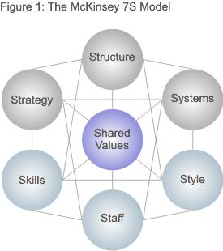
Figure reproduced with permission from Mckinsey & Company, www.mckinsey.com. Copyright © 2016. All rights reserved.

Let's look at each of the elements specifically:
- Strategy: the plan devised to maintain and build competitive advantage over the competition.
- Structure: the way the organization is structured and who reports to whom.
- Systems: the daily activities and procedures that staff members engage in to get the job done.
- Shared Values: called "superordinate goals" when the model was first developed, these are the core values of the company that are evidenced in the corporate culture and the general work ethic.
- Style: the style of leadership adopted.
- Staff: the employees and their general capabilities.
- Skills: the actual skills and competencies of the employees working for the company.

Placing Shared Values in the middle of the model emphasizes that these values are central to the development of all the other critical elements. The company's structure, strategy, systems, style, staff and skills all stem from why the organization was originally created, and what it stands for. The original vision of the company was formed from the values of the creators. As the values change, so do all the other elements.
1.4.2 How to Use the Model
The model is based on the theory that, for an organization to perform well, these seven elements need to be aligned and mutually reinforcing. So, the model can be used to help identify what needs to be realigned to improve performance, or to maintain alignment (and performance) during other types of change.
Whatever the type of change – restructuring, new processes, organizational merger, new systems, change of leadership, and so on – the model can be used to understand how the organizational elements are interrelated, and so ensure that the wider impact of changes made in one area is taken into consideration.

1.4.3 The 7-S Checklist Questions
Here are some of the questions that you'll need to explore to help you understand your situation in terms of the 7-S framework. Use them to analyze your current (Point A) situation first, and then repeat the exercise for your proposed situation (Point B).

Strategy:
- What is our strategy?
- How do we intend to achieve our objectives?
- How do we deal with competitive pressure?
- How are changes in customer demands dealt with?
- How is strategy adjusted for environmental issues?

Structure:
- How is the company/team divided?
- What is the hierarchy?
- How do the various departments coordinate activities?
- How do the team members organize and align themselves?
- Is decision making and controlling centralized or decentralized? Is this as it should be, given what we're doing?
- Where are the lines of communication? Explicit and implicit?

Systems:
- What are the main systems that run the organization? Consider financial and HR systems as well as communications and document storage.
- Where are the controls and how are they monitored and evaluated?
- What internal rules and processes does the team use to keep on track?

Shared Values:
- What are the core values?
- What is the corporate/team culture?
- How strong are the values?
- What are the fundamental values that the company/team was built on?

Style:
- How participative is the management/leadership style?
- How effective is that leadership?
- Do employees/team members tend to be competitive or cooperative?
- Are there real teams functioning within the organization or are they just nominal groups?

Staff:
- What positions or specializations are represented within the team?
- What positions need to be filled?
- Are there gaps in required competencies?

Skills:
- What are the strongest skills represented within the company/team?
- Are there any skills gaps?
- What is the company/team known for doing well?
- Do the current employees/team members have the ability to do the job?
- How are skills monitored and assessed?

1.4.4 The 7-S Matrix Questions
Using the information you have gathered, now examine where there are gaps and inconsistencies between elements. Remember you can use this to look at either your current or your desired organization.
- Start with your Shared Values: Are they consistent with your structure, strategy, and systems? If not, what needs to change?
- Then look at the hard elements. How well does each one support the others? Identify where changes need to be made.
- Next look at the other soft elements. Do they support the desired hard elements? Do they support one another? If not, what needs to change?
- As you adjust and align the elements, you'll need to use an iterative (and often time consuming) process of making adjustments, and then re-analyzing how that impacts other elements and their alignment. The end result of better performance will be worth it.

